**BANGLADESH UNIVERSITY OF BUSINESS AND TECHNOLOGY**

**(BUBT)**



**Lab Report**

Course Code : CSE 324

Course Title : Compiler Design Lab

Date of Submission : April 29, 2024

Submitted By

Name : Aktaruzzaman

ID : 21222203031

Intake : 41

Section : 1

Submitted To

**Ms. Adeeba Anis**

Lecturer

Department of Computer Science & Engineering

Bangladesh University of Business and Technology (BUBT)

**Experiment No: 0**8

**Experiment No: 8**

**Experiment Name:** Implementing LL(1) Parser for Given Grammar

**Problem Structure**

The goal of this experiment is to implement an LL(1) parser for a given grammar. The grammar is as follows:

X -> xYx

Y -> yY

Y -> ε

The LL(1) parser aims to determine whether a given input string belongs to the language defined by the grammar.

**Procedure**

* Define the grammar productions in a unordered_map<char, vector<string>> data structure.
* Take the input string from the user.
* Initialize the stack with the start symbol followed by $ and append the input string with $.
* Iterate through the input string and stack until the parsing process is complete:
  + If the top of the stack and the current input character match, pop both from the stack and input.
  + If the top of the stack is a non-terminal, replace it with its production rule.
  + If the top of the stack is a terminal and doesn't match the current input, the parsing fails.
* If the stack and input are both empty, or if both contain only the $ symbol, the parsing is successful.

**Code:**

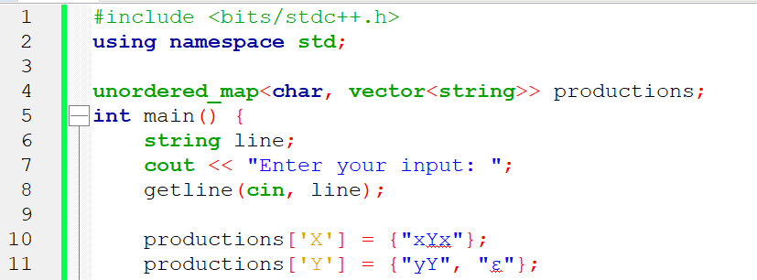

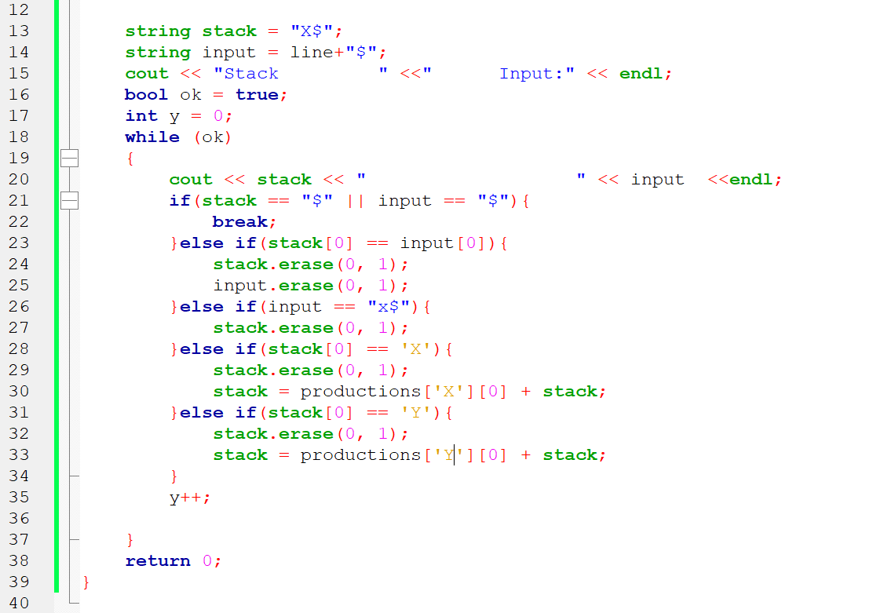

**Input and Output**

